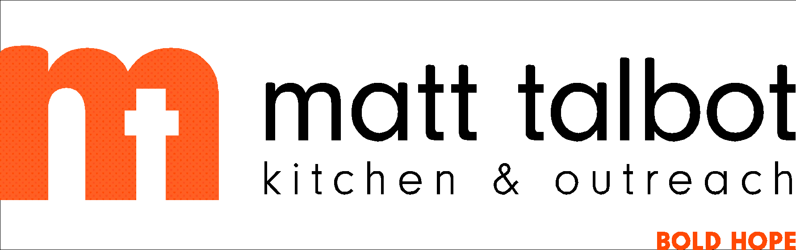

**Souper Bowl of Caring 2024**

**Bulletin Announcements**

If you decide to join the **Souper Bowl of Caring** team in support of Matt Talbot Kitchen & Outreach, please also consider running these **Souper Bowl of Caring** announcements in your church bulletin or group’s newsletter prior to the BIG GAME on February 11th. These announcements are available on our website ([www.mtko.org](http://www.mtko.org)) and other promotional resources are available at [www.souperbowl.org](http://www.souperbowl.org). Thank you!

__________________________________________________________________________________________

**Announcement 1**

In 1990, Souper Bowl of Caring began with a simple prayer from a single youth group: **“Lord, even as we enjoy the Super Bowl football game, help us be mindful of those without a bowl of soup to eat.”** Since then, more than $170 million has been generated for local charities across the country through Souper Bowl of Caring.

It has become a powerful movement that transforms the time around the Big Game into the nation’s largest celebration of giving and caring for those in need.

Through this mission, people learn they can make a positive difference in the world as they collect food, raise money and serve at hunger-relief charities and show caring and compassion in local communities across the country.

Share in God’s love for our neighbors in need and give generously on **February 11th**. All of the donations collected will go directly to Matt Talbot Kitchen & Outreach.

**Announcement 2**

On the weekend of **February 11th**, millions of Americans will watch the BIG GAME. There will be parties with abundant food, friendship, and fellowship. You can help make sure everyone has soup in their bowls by participating in **Souper Bowl of Caring**! Let’s join with others around the country as we demonstrate God’s love by loving our neighbors through the **Souper Bowl of Caring**. It’s a simple, yet significant act of caring for others.

This year we will be collecting for Matt Talbot Kitchen & Outreach in Lincoln. For over 30 years Matt Talbot Kitchen & Outreach has served the homeless and near homeless. Feeding the hungry is at the core of their mission.

Drop $1 or more in the soup pot as you leave worship on February 11th. Thanks for supporting this effort and helping those most vulnerable in our community.